**INNOVATION IN TELEMEDICINE IN RURAL AREAS**

**PROBLEM STATEMENT:**

Understanding unique challenges, improving access to healthcare Understanding unique challenges, improving access to healthcare, addressing [health disparities](https://www.sciencedirect.com/topics/pharmacology-toxicology-and-pharmaceutical-science/health-disparity), and improving [healthcare delivery](https://www.sciencedirect.com/topics/computer-science/healthcare-delivery) models require research into the rural healthcare system. Rural areas face unique challenges, such as limited access to facilities, professional healthcare shortages, transportation barriers, and socioeconomic disparities.[3](https://www.sciencedirect.com/science/article/pii/S2949866X23000576#bib3) Researchers can identify access barriers and devise novel approaches to improve healthcare delivery, such as telehealth, mobile clinics, community health workers, and policy interventions. Understanding rural healthcare aids in identifying the root causes of disparities and developing interventions to address them. Research on the rural healthcare system informs policy and decision-making, allowing for the development of effective rural healthcare delivery models.[4](https://www.sciencedirect.com/science/article/pii/S2949866X23000576#bib4) Medical 4.0 in healthcare relies on supply chain management using [AI](https://www.sciencedirect.com/topics/computer-science/artificial-intelligence), big data analytics, and [IoT.](https://www.sciencedirect.com/topics/computer-science/internet-of-things) Thorough research and education are essential for efficient, reliable delivery of medical products and services. The need for studying supply chain management in rural hospitals within the Medical 4.0 environment is to draw attention to the practical applications and address the observed challenges. Researchers can identify and understand rural hospitals' specific issues in adopting Medical 4.0 technologies and practices it. Therefore, it is important to be innovative and make an easily accessible website which can be used in the backward rural areas where accessibility is in low rate.

**ABSTRACT:**

Health is crucial for personal happiness, productivity, and fulfillment. It impacts physical well-being, mental health, longevity, academic and professional success, and interpersonal relationships. It reduces healthcare costs, contributes to economic growth, and promotes community well-being. This paper explores the status of the healthcare system in rural India. Paper reviews available research and also collects data from rural hospitals. However, addressing these complex issues requires continuous efforts, adequate funding, and proactive measures in healthcare infrastructure, workforce development, and policy reforms. The presented data reflects rural areas' ongoing challenges, underscoring the pressing need for proper treatment and care. By prioritizing the presented aspects, the healthcare landscape in rural India can witness positive transformations and ensure improved healthcare outcomes for its population. In this project, the various possible problems and its solutions can be addressed which can be seen while visiting hospitals and can be rectified the drawbacks that it faced by the management as well as by the patients especially in rural areas.

**SOFTWARE REQUIREMENTS:**

OPERATING SYSTEM: Windows 7 or XP OR Windows 8.

FOR DATABASE: MySQL

FRONT END:

No additional software installations needed.

**INTRODUCTION:**

Telemedicine is a health-related service with the help of telecommunicating and electronic information technologies. It refers to the whole collection of deliverables designed to enable patients and their physicians or healthcare providers. It has a wide range of uses, including online patient consultations, remote control, telehealth nursing, and remote physical and psychiatry rehabilitation. It allows better health care choices, increases emergency service quality and performance, reduces time in making a diagnosis, and saves costs for both doctors and patients by optimizing clinical procedures and reducing travel expenses to hospitals. Telemedicine is a more beneficial technology that can make it easier for people to get preventive treatment and help their long-term health. It is particularly true for those who face financial or regional causes to receive quality treatment. Telehealth has the potential to make health care more effective, organized, and available. The research on this area is still in its early stages, but it is expanding. For example, telephone-based care and telemonitoring of vital signs in persons with heart disease decreased the risk of mortality and hospitalization and increased quality of life. There are several compelling reasons for people to get a diagnosis or recovery plan. This can make patients feel assured that they are receiving the best quality treatment. Telemedicine is an excellent choice for treating mental health issues. It eliminates some of the causes that prevent patients from receiving this critical form of treatment. Telemedicine technology holds great promise for patients in remote areas. The most significant effect is provided in various countries where healthcare facilities are both scarce and unavailable. To ensure an accurate medical history, all patients and doctors must have sufficient hardware and software security in place. Some clinics can provide virtual appointments with a doctor through online video conferencing. When an in-person visit is not required or necessary, these appointments enable them to continue receiving treatment from a usual doctor. Web-based visits with a doctor or nurse practitioner are another form of interactive appointment. As part of their health care offerings, several major corporations have access to automated doctor's offices.

**FLOW CHART:**

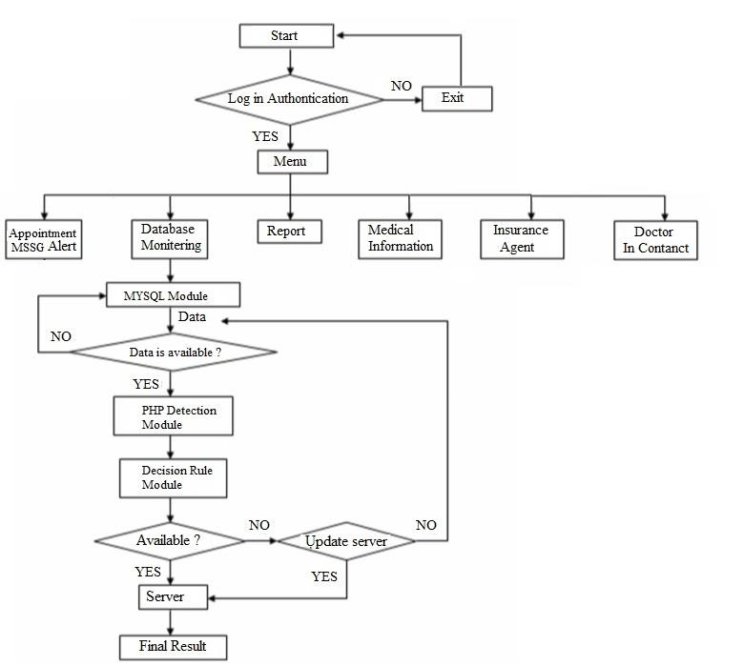

**E-R DIAGRAM:**

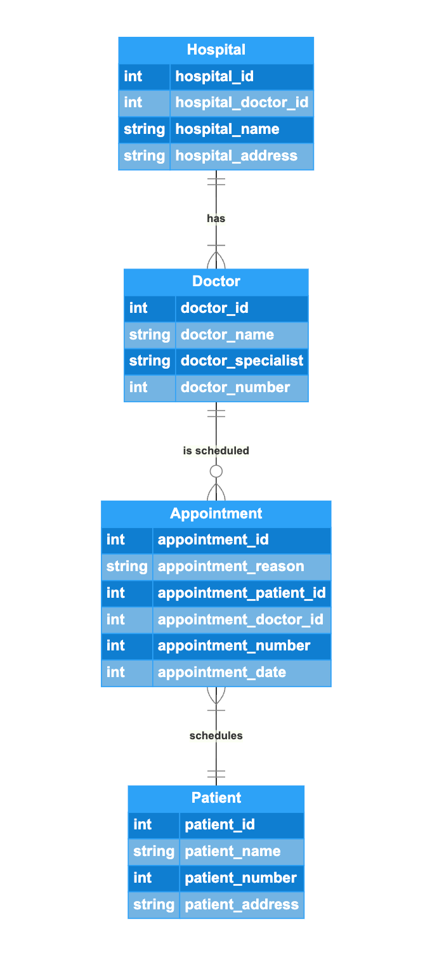

**ADVANTAGES:**

It allows better health care choices, increases emergency service quality and performance, reduces time in making a diagnosis, and saves costs for both doctors and patients by optimizing clinical procedures and reducing travel expenses to hospitals. Telemedicine is a more beneficial technology that can make it easier for people to get preventive treatment and help their long-term health. Easier and simple to use and accessibility is more convenient.

**DISADVANTAGES:**

Network connectivity can be a cause for distant or improper communication between the handling doctor and their patient.